PROJECT REPORT: DIGITAL IC DESIGN TRACK
GROUP MEMBERS:
Manana Samanta (BTECH/10278/24), Rajdeep Kumar (BTECH/10275/24)
TOPIC:
Design and implementation of a Dual-edge triggered Flip-Flop capable of capturing input data on both rising and falling edges.
THEORY:
Our schematic consists of two parallel master slave based edge-triggered registers, whose outputs are multiplexed using the tri-state drivers. When clock is high, the positive latch composed of transistors (PM0, PM1, NM0, NM1) is sampling the inverted D input on node X. Node Y is held stable, since devices PM6 and NM6 are turned off. On the falling edge of the clock, the top slave latch (PM2, PM3, NM2, NM3) turns on, and drives the inverted value of X to the Q output. During the low phase, the bottom master latch (PM1, NM0, PM6, NM6) is turned on, sampling the inverted D input on node Y. It is to be noted that the devices PM1 and NM0 are reused, reducing the load on the D input. On the rising edge, the bottom slave latch conducts, and drives the inverted version of Y on node Q. Data hence changes on both edges. The slave latches operate in a complementary fashion — that is, only one of them is turned on during each phase of the clock.
SCHEMATIC:
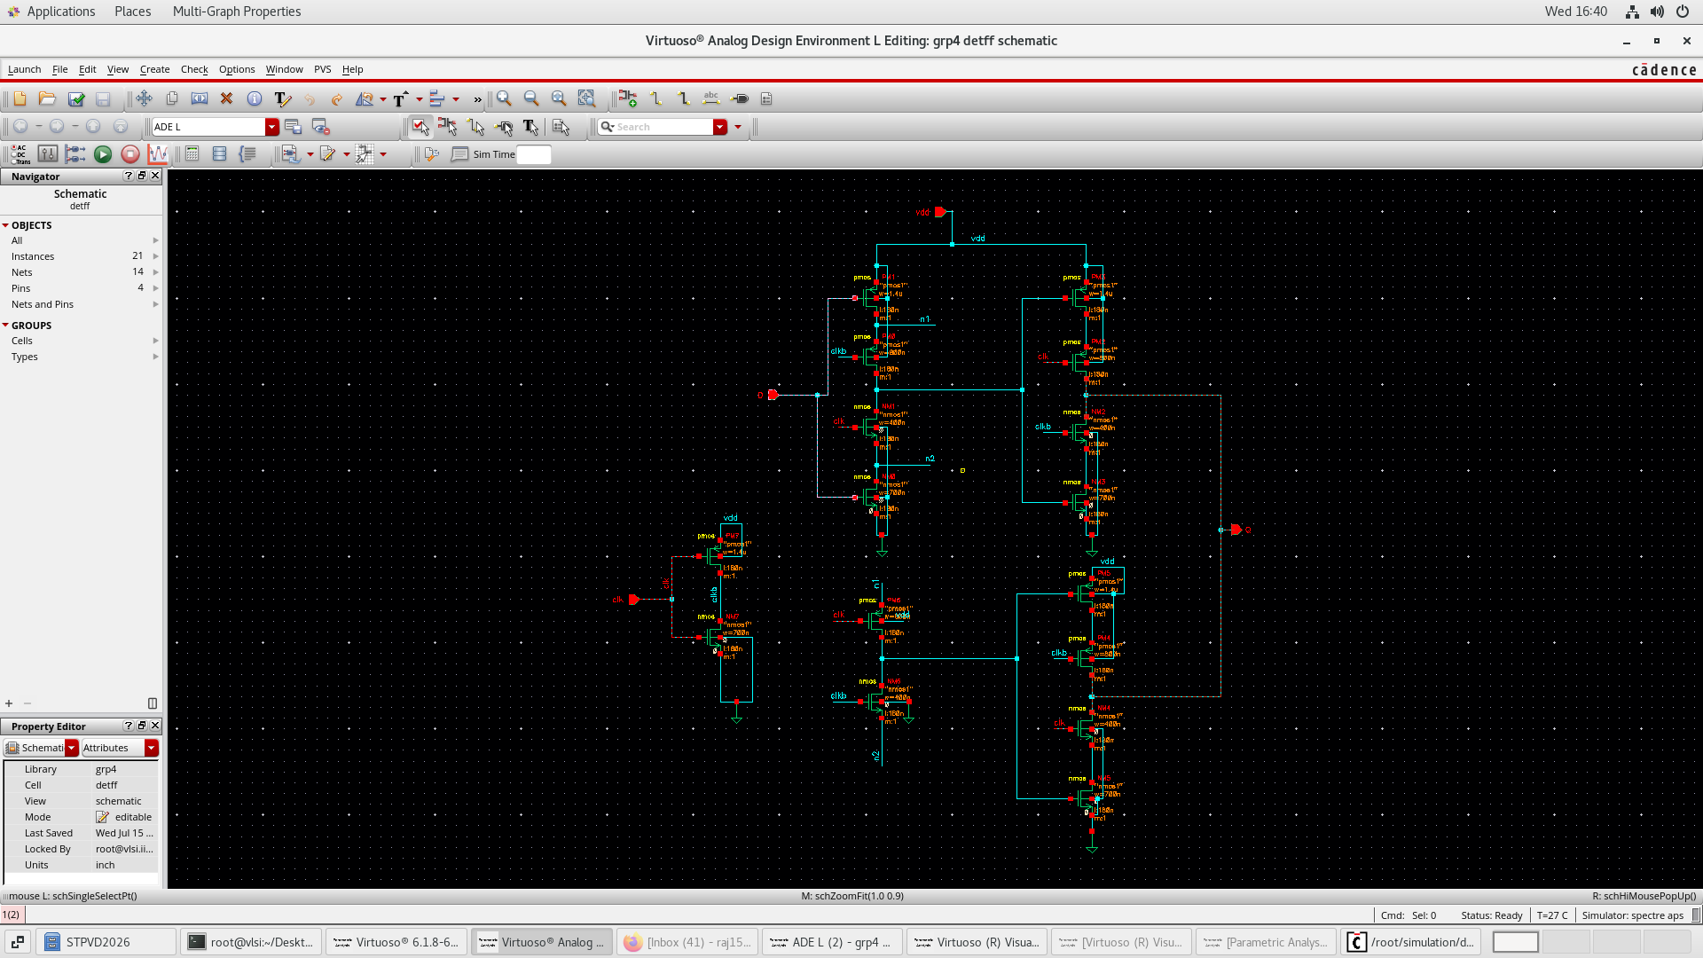

In the proposed schematic, the gpdk 180 technology node has been incorporated. The value of VDD is fixed at 1.8 V. The width of all the clocked pmos has been set to 800 nm, while that of clocked nmos has been set to 400 nm. The width of rest of the pmos are 1.4um, and that of nmos are 700nm.
The following waveform is indicative of the pre-layout simulation.
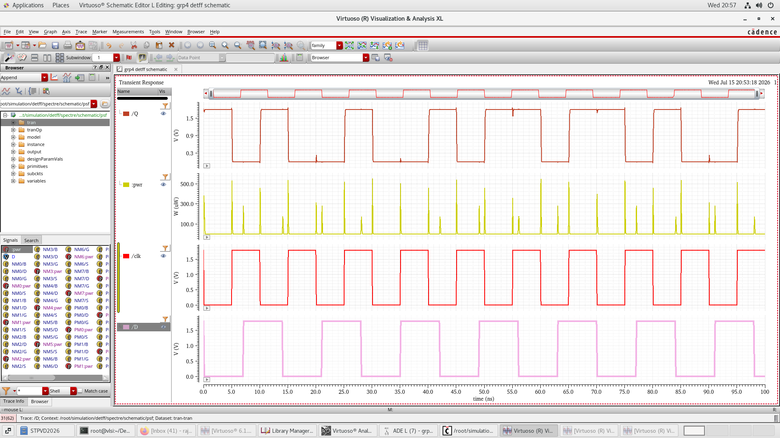
Simulation waveform of pre-layout circuit
POWER CONSUMPTION:
A parametric analysis of power consumption has been performed to determine its variation with the time period of clock (i.e, the operating frequency). The optimised power value is 8.94 uW with time period of clock pulse as 10 ns, while that of pulse input D as 17 ns.
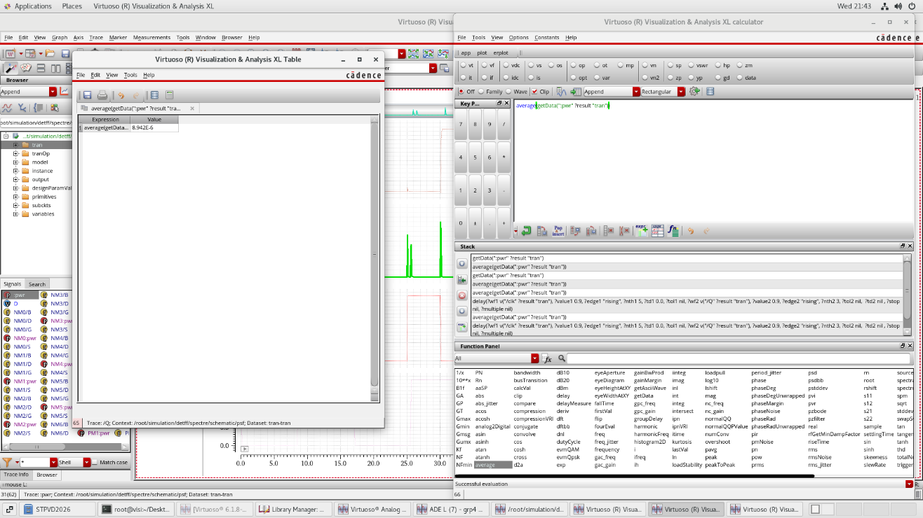
Power consumption of pre-layout circuit

TIMING REPORT:
Propagation Delay:
The clock-to-Q delay has been calculated for both the rising and falling edges of the clock and the output Q. The worst-case delay among the four scenarios is reported to be 94.22 ps.
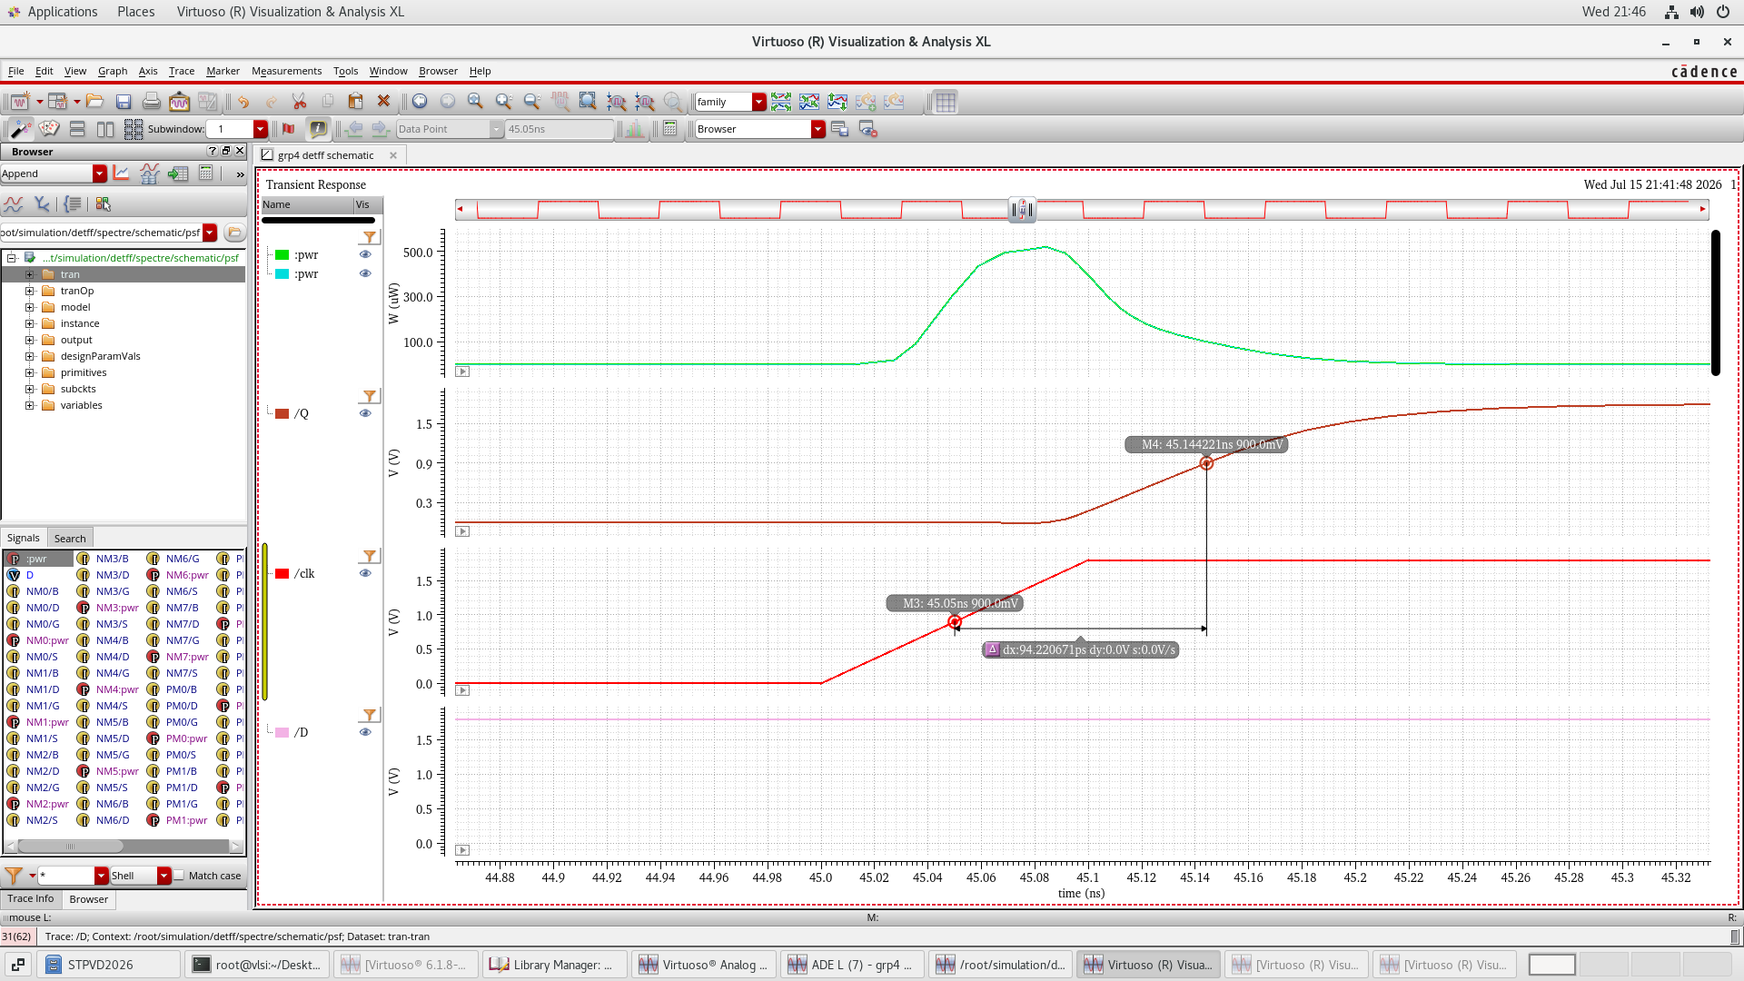
Propagation delay of pre-layout circuit
Setup Time: The worst-case setup time of the circuit is 157.89 ps.
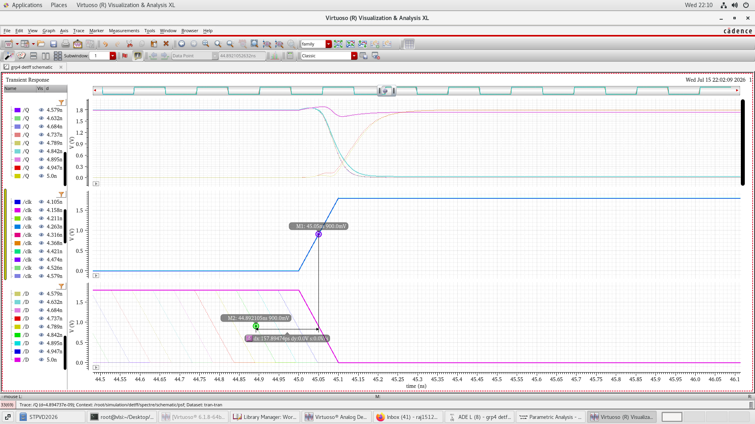
Setup time of pre-layout circuit
LAYOUT:
A layout of circuit was created after optimisation, followed by DRC and LVS checks. After zero DRC and LVS errors, parasitic extraction (PEX) was performed taking into consideration all parasitic resistances and capacitances.
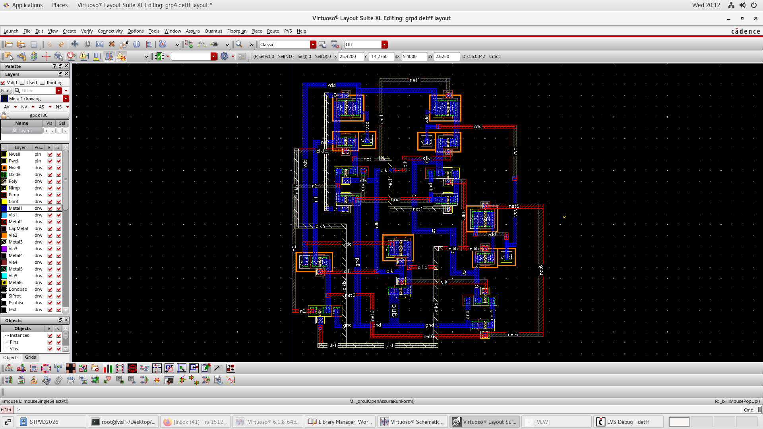
Layout of circuit
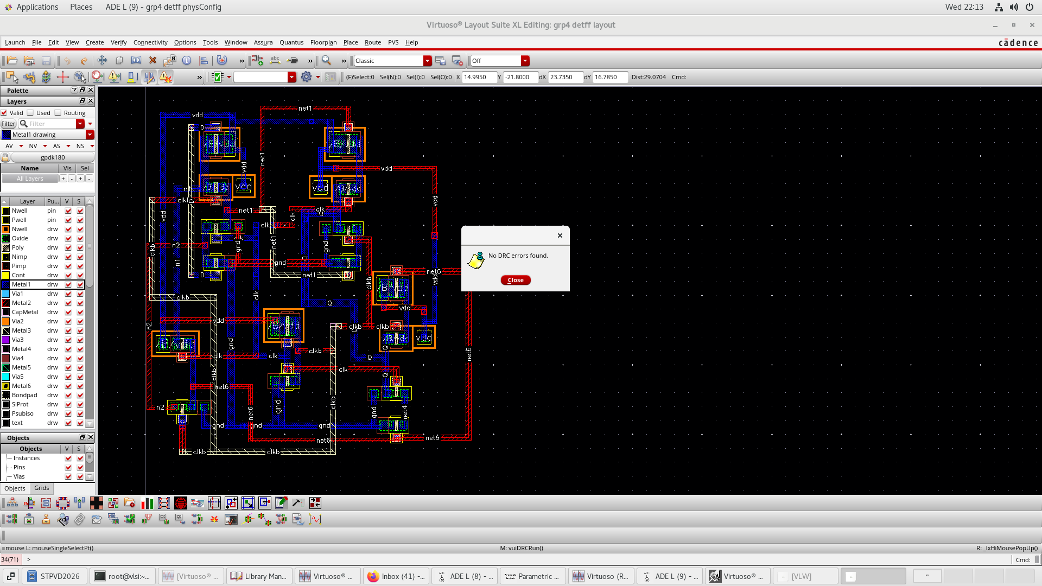
DRC clean layout
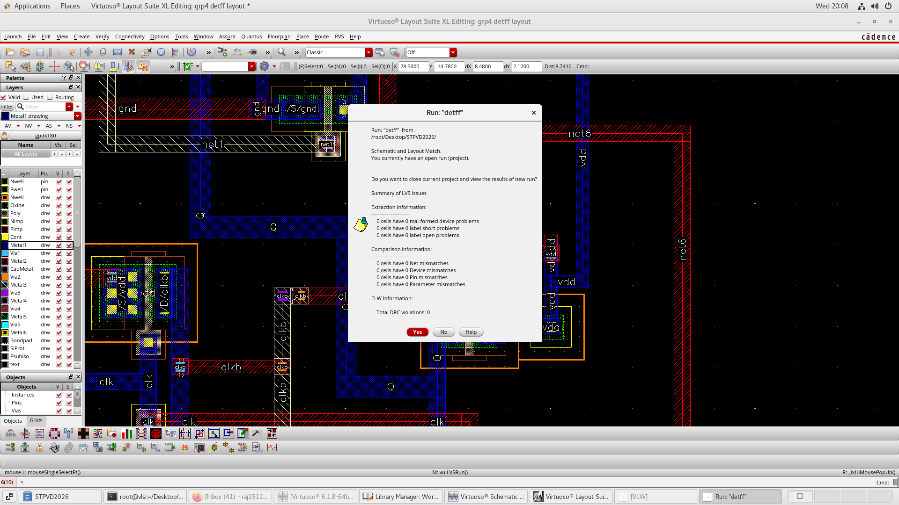
LVS clean layout
POST LAYOUT OBSERVATIONS:
The worst-case propagation delay and setup time of post layout simulation was found to be 149.91 ps and 263.158 ps respectively. The power consumption after post layout was calculated as 14.49 uW.
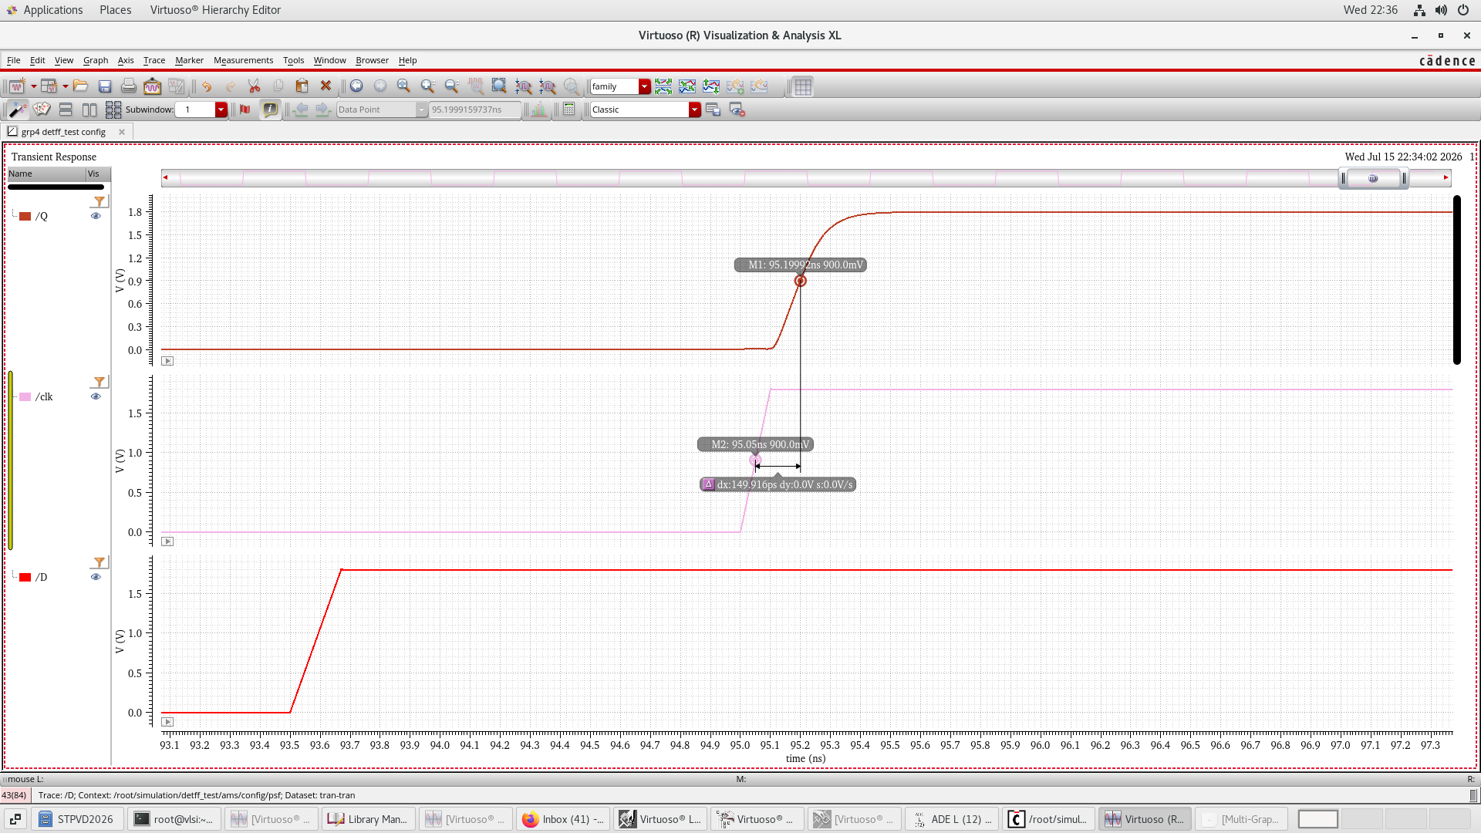
Propagation delay after post -layout simulation
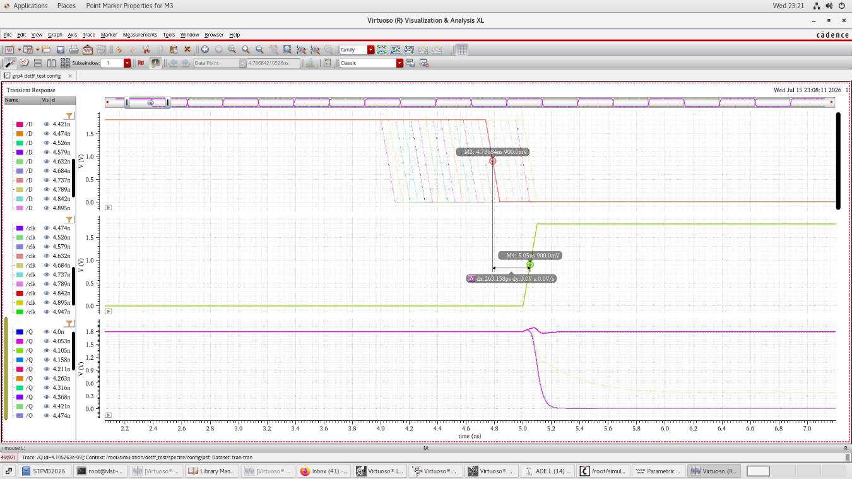
Post layout setup time
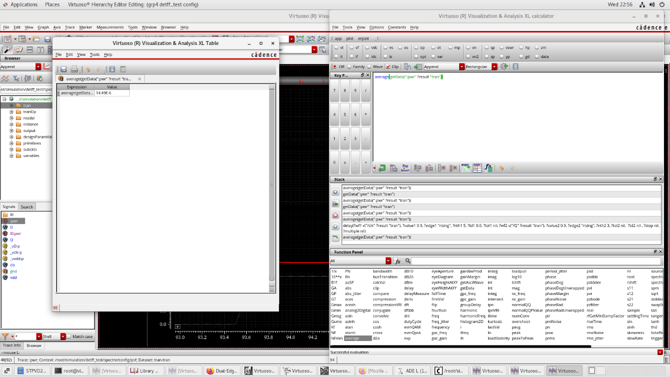
Dynamic power consumption following post layout simulation
CONCLUSION:
The advantage of the design is that it achieves the same throughput as a conventional single-edge triggered flip-flop while operating at half the clock frequency, thereby reducing dynamic power consumption in the clock distribution network. The flip-flop is optimized for low power leading to a massive reduction in power. The high speed operation is also kept in mind, thereby producing a small propagation delay, thereby leading to a significant optimisation of power-delay product (PDP).

